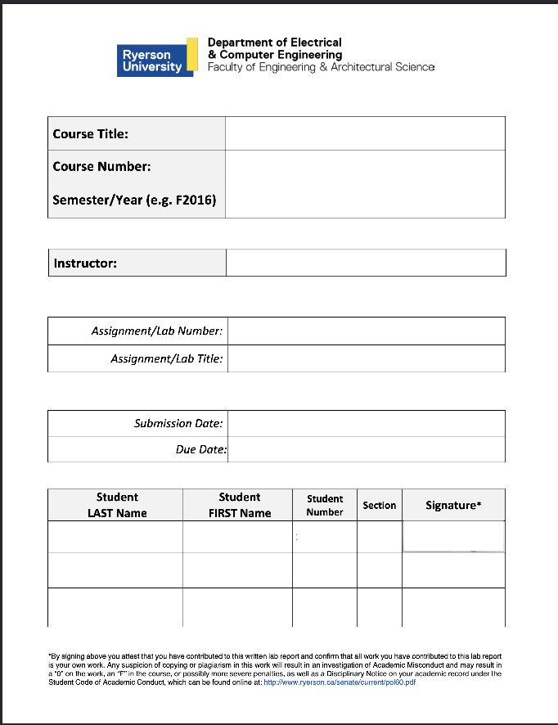
Electronic Circuits 1

P2024
Jassar, Surinder
7
CC Amplifier
June 17, 2024
June 17, 2024
Mourad Shai
04
501170415
Sharma
Tanishq
501122854
04
TS
Table of Content
1. Introduction...........................................................................................R
2. Objectives..............................................................................................R
3. Circuit under Test..................................................................................R
4. Experimental Results............................................................................R
5. Conclusions and Remarks.....................................................................R
6. Appendix: Signed Pre-Lab and TA Copy of Results...............................R

Introduction

The report for Lab 7, CC Amplifier, is presented here. This lab took place on June 14, 2024. The TA’s signed copy and the pre-lab are included in Appendix.

Objectives
The objective of this lab was to investigate and examine Common-Collector BJT Amplifiers and familiarize ourselves with buffering. Through this we gain the opportunity to analyze a two stage amplifier. The circuit provided in the lab manual was built and results were found using an oscilloscope, voltage source, and ammeter

Circuit under Test
The Circuits below were used for the prelab:

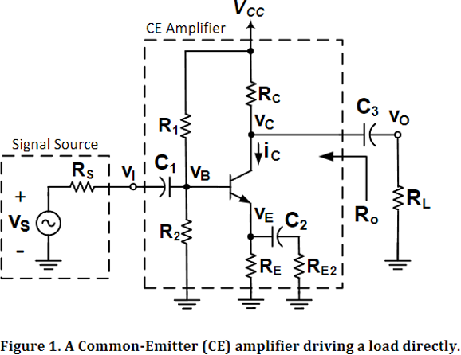

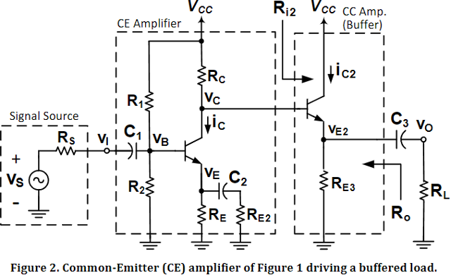

The circuits below were used for the in lab experiment:
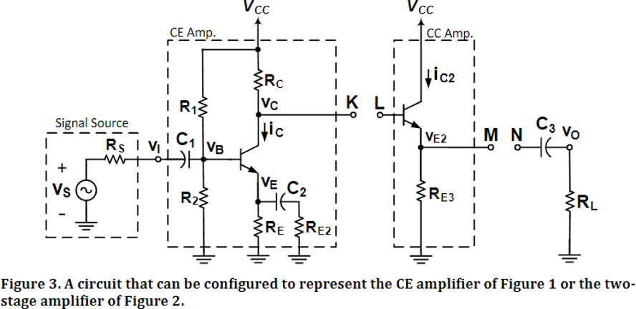

Experimental Results

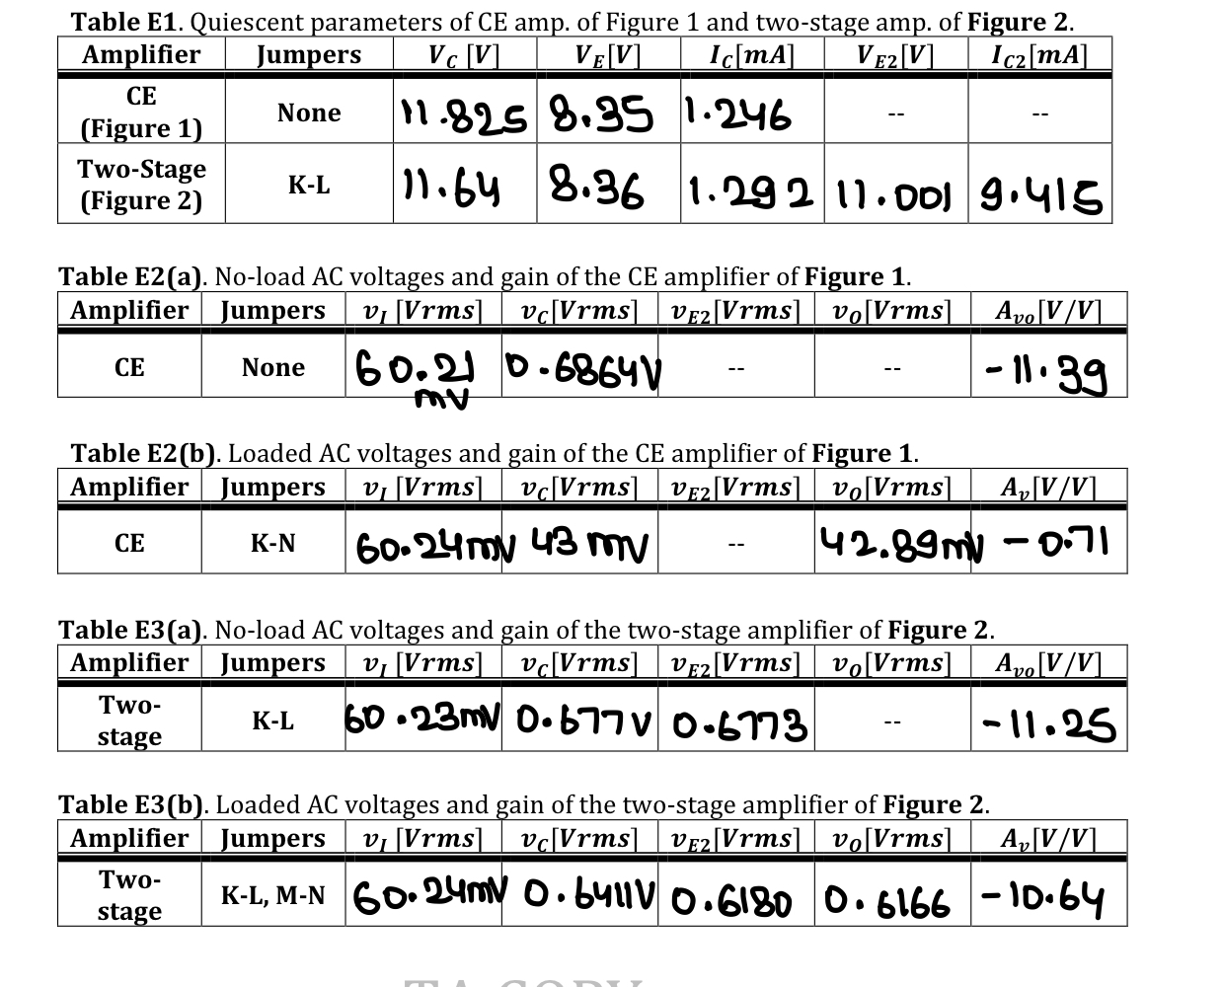

Conclusion and Remarks:
C1:
Table C1(a). Calculated and measured (DC) voltages of CE amplifier of Figure 1.
 | V_{C} [V] | V_{E} [V] | V_{E2} [V]
Calculate Values (from Table P1) | 12.009 | 7.584 | - - - -
Measured Values  (first column, Table E1) | 11.825 | 8.358 | - - - -
Percent Error, 𝑒 % | 1.556% | 9.261% | - - - -

Table C1(b). Calculated and measured (DC) voltages of the two-stage amplifier of Figure 2.
 | V_{C} [V] | V_{E} [V] | V_{E2} [V]
Calculate Values (from Table P2) | 11.845 | 7.784 | 11.145
Measured Values  (first column, Table E1) | 11.640 | 8.360 | 11.001
Percent Error, 𝑒 % | 1.761% | 6.810% | 1.309%

The percent errors for V_{C}​ in both tables are low, indicating a good match between calculated and measured values, but the errors for V_{E}​ are higher, especially in Table C1(a). These discrepancies can be attributed to component tolerances, measurement inaccuracies, and temperature variations affecting component behavior. Additionally, ideal assumptions in calculations do not always account for real-world conditions like parasitic resistances and capacitances in the circuit.

C2:

Table C2(a). Calculated and measured voltage gain of the CE amplifier of Figure 1.
 | A_{V} [V/V] | A_{Vo} [V/V]
Calculate Values (from Table P1) | -0.7137 | -11.42
Measured Values  (first column, Tables E2 (a) and (b)) | -0.7138 | -11.39
Percent Error, 𝑒 % | 0.014% | 0.2634%

Table C2(b). Calculated and measured (DC) voltages of the two-stage amplifier of Figure 2.
 | A_{V} [V/V] | A_{Vo} [V/V]
Calculate Values (from Table P2) | -11.22 | -11.39
Measured Values  (first column, Tables E3 (a) and (b)) | -10.64 | -11.25
Percent Error, 𝑒 % | 5.45% | 1.24%

The percent errors for voltage gain A_{V}​ and open-loop voltage gain A_{Vo}​ in Table C2(a) are very low, at 0.014% and 0.2634%, respectively, indicating a close match between calculated and measured values. In Table C2(b), the errors are slightly higher, with A_{V} at 5.45% and A_{Vo}​ at 1.24%, but still reasonably small. These discrepancies can be due to component tolerances, measurement inaccuracies, and slight differences in the operating conditions between the theoretical calculations and practical measurements. Additionally, real-world factors like parasitic elements and variations in the power supply can contribute to these differences.

The common-collector (CC) stage in the two-stage amplifier allows us to handle a heavy load by modifying the load's impact. This change affects the voltage gain as follows:

$\frac{V_{o}}{V_{B2}}$

And can be written as:
$\frac{x}{x + \frac{1}{R_{L}}}$
With $\frac{1}{R_{L}}$ << x. Since it is much smaller than x, the ratio is essentially: $\frac{x}{x} = 1$. The voltage gain remains stable and consistent, and another perspective is to consider the input resistance of the common-collector (CC) amplifier both with and without the load, as well as the output load (R_{o2}).
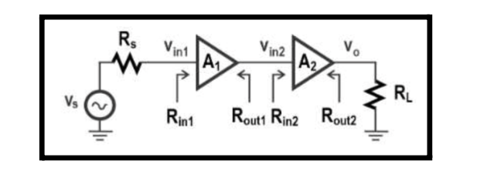

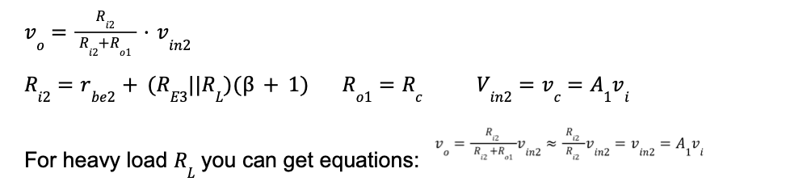
This demonstrates that the gain remains approximately unchanged whether there is a load or not. Hence, the CC amplifier functions as a buffer, offering a consistent voltage gain independent of R_{L}.
​
Appendix: Signed Pre-Lab and TA Copy of Results
*PRE LAB INCLUDED SEPARATELY*

